Rear Admiral Jeffrey A. Jurgemeyer
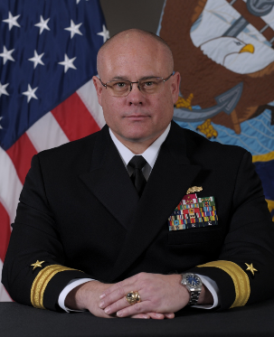
Rear Admiral Jeff Jurgemeyer is a native of Mission Viejo, California, and a career surface warfare officer. He graduated from the United States Naval Academy in 1993, earning a Bachelor of Science in History, and went on to earn a Master of Science in Financial Planning. He is a Level III Joint Specialist Officer, having completed Joint Professional Military Education (JPME) Phase I through the Air Command and Staff College and Advanced JPME at the Joint Force Staff College. Additionally, he graduated from the Reserve Component National Security Course, Navy Senior Leader Seminar, and the Darden School of Business’ Navy Strategic Thinking Course.
Following his completion of Surface Warfare Officer School, he served at sea aboard USS VANDEGRIFT (FFG 48) as Damage Control Assistant and USS JOHN PAUL JONES (DDG 53) as Strike Warfare Officer. Ashore, he served as an Officer Recruiter assigned to Navy Recruiting District San Diego, CA.
In the Navy Reserve, Rear Admiral Jurgemeyer’s command tours include Reserve Commodore, Littoral Combat Ship Squadron ONE, Surface and Mine Warfighting Development Center Headquarters, Naval Surface Force, U.S. Pacific Fleet Afloat Culture Workshop Detachment, and U.S. Pacific Fleet, Logistics Readiness Support Detachment Alpha.
Additionally, he held various leadership positions while serving in the Reserves, to include Reserve Chief of Staff, Naval Surface Force, U.S. Pacific Fleet and Reserve Surface Warfare Deputy Community Lead, NORAD-NORTHCOM J33, U.S. THIRD Fleet Maritime Air Operations detachment Las Vegas, and Expeditionary Port Unit 119.
Rear Admiral Jurgemeyer completed two one-year mobilizations as the Maritime Fires Officer, U.S. Pacific Fleet, and operations officer, Force Strategic Engagement Cell, Multi-National Force Iraq in support of OPERATION IRAQI FREEDOM.
His awards include the Legion of Merit (2), the Bronze Star Medal, Meritorious Service Medal (3), Navy and Marine Corps Commendation Medal (4), Navy and Marine Corps Achievement Medal (3), and various campaign medals and unit awards.

